SENIOR STRENGTH – KEEPING STRONG
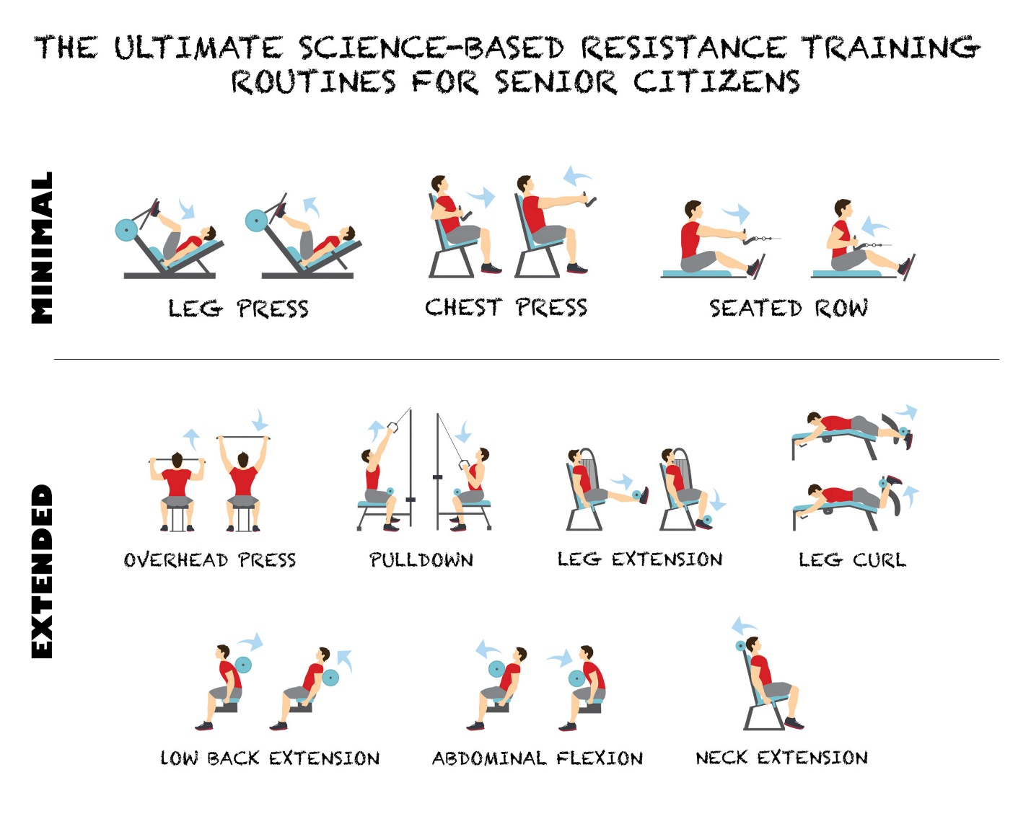
PARKS & RECREATION SENIOR STRENGTH CLASSES
WEDNESDAYS 12:30 CENTER HARBOR MUNICIPAL BUILDING CARY MEAD ROOM $5.00 PER SESSION
STARTS SEPTEMBER 27, 2023
CONTACT: PARKSANDRECREATION@CENTERHARBORNH.GOV

