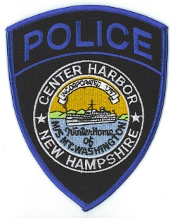
Town of Center Harbor
POLICE DEPARTMENT
36 Main Street/PO Box 140
Center Harbor, NH 03226
603-253-9756 (Dispatch)
603-253-8241 (Fax)
Mark C. Chase
Chief of Police
Detail Request Form

Date of Detail: _________________________________________________________________

Officer Assigned: _________________________________________________________________

Location of Detail: _________________________________________________________________

Start Time: ____________________ End Time: ________________ Total Hours: ________

Reason for Detail: _________________________________________________________________

Cruiser Used: Yes ___________ No ____________

Person/Company Requesting Detail: ____________________________________________________

Billing Information

The detail rate is $75.00 per hour with a four (4) hour minimum. Additionally, there is a cruiser charge of $10.00 per hour with a four (4) hour minimum. Checks should be made out to the Center Harbor Police Department. If there are any questions, please call the Center Harbor Police Department at our 24-hour number, 603-253-9756. This is not a bill but a receipt for the services provided to you. The actual invoice will be mailed to the individual/company requesting the officer. Thank you.

Company: _________________________________________________________________

Address: _________________________________________________________________

_________________________________________________________________

_________________________________________________________________

Telephone: _________________________________________________________________

Supervisor/Manager Authorizing Detail: ____________________________________________________

