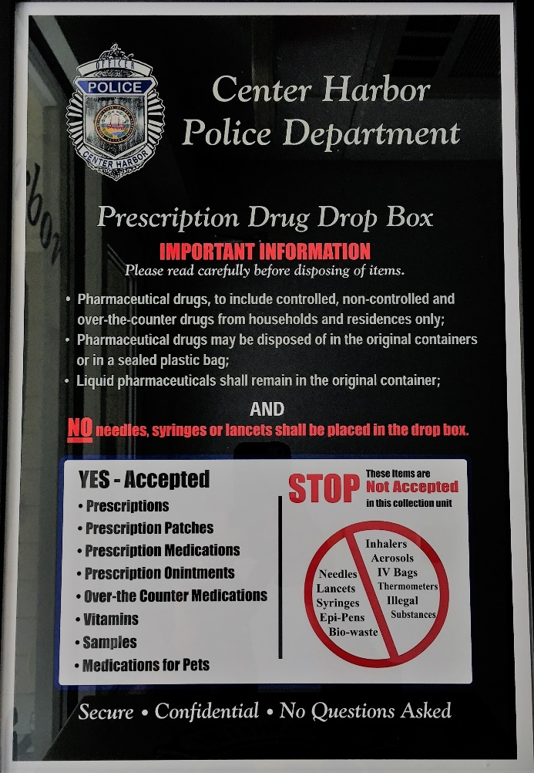
The Town of Center Harbor Police Department, in collaboration with the Moultonborough Lions Club, have recently initiated a Pharmaceutical Drug Collection and Disposal Program for the overall safety of our Center Harbor community. Through the generous donation from the Moultonborough Lions Club, a brand new, permanent, drug drop box has been installed in the lobby of the Town of Center Harbor Municipal Building, beside the public access window to the Center Harbor Police Department.
Prescription drugs are often misused due to increased availability and easy access to a variety of unused medications in the home. Now, with the installation of our new permanent drug drop box, Center Harbor community members, as well as those visiting the area, have an easy, safe and secure way of disposing extra, unwanted or expired prescription drugs. This type of drug drop off is SECURE, CONFIDENTIAL, and with NO QUESTIONS ASKED
Local businesses and community members who aided and supported the Center Harbor Police Department with this community program are : Moultonborough Lions Club for their donation of funds to purchase and outfit the drop box, Advanced Lock and Alarm for donating their time and efforts to install a second locking mechanism on the drop box, Just Hit Print for donating their time and efforts with the installation of stickers now located on the collection box and Town of Center Harbor Code Enforcement Officer Ken Balance for permanently installing the drop box in the Police Department lobby area of the Municipal Building.
The drop box will be available for public use during normal Town of Center Harbor Municipal Building hours (Monday 9:00AM - 3:00PM, Tuesday 9:00AM - 3:00PM, Wednesday 9:00AM - 12:00PM 6:00PM - 8:00PM, Thursday 9:00AM - 3:00PM and Friday 9:00AM - 3:00PM).
NO SHARPS ALLOWED IN THE DROP BOX.
