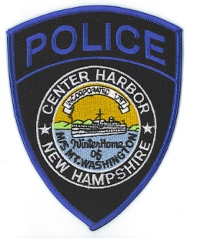
Town of Center Harbor
POLICE DEPARTMENT
36 Main Street/PO Box 140
Center Harbor, NH 03226
603-253-9756 (Dispatch)
603-253-8241 (Fax)
Mark C. Chase
Chief of Police
Right to Know / Report Request

Please Print:
Name

Mailing Address

Contact Phone Number

The Center Harbor Police Department reserves the right to withhold any and all information that may jeopardize any police investigation and/or any information that may violate the rights of victims, juveniles or any person involved in an accident. Accident reports may only be obtained by the person involved and/or their insurance carriers.

Please provide the date (or approximate), the location and a brief description of the nature of the incident you are requesting the report on:

Fees: Incident/Arrest/Accident $10.00
All other requests $1.00 per page@ ___________ pages Total $ _______________

___ I would like the report(s) mailed to the above address
___ I will pick up the report(s) when ready

Office Use Only
Call For Service __________________
Incident Report __________________
Arrest Report __________________
Accident Report __________________

___ Granted Date Mailed or Picked Up_____________________________________________
___ Denied Reason ___________________________________________________________

